Cube Humidity Controller - Documentation

Leaf Controller

[24th February 2021]

Document Control Number:

Revision Number: 0.1

Expiration Date:

Author: Georg Kordowich

Approval: ____________________________________

Revision History

|  |  |  |
| --- | --- | --- |
| Date | Revision Number | Pages Affected |
| 20th February 2021 | 0.1 | Initial release |

Table of Contents

1. Using the Modbus Script 2

1.1 Using the Modbus Script with command line arguments 2

1.1.1 Setting the IP-Address and Port of the Clients 3

1.1.2 Reading devices from the command line 4

1.1.3 Advanced Settings (Cyclic Reading, Server function). 4

1.1.4 Reading and writing single devices manually 5

1.2 Using the Modbus Script with a config file 7

2. Internal structure of the script 9

2.1 Settings and Configuration 9

2.2 Main Components 9

2.3 Definition of devices 10

2.4 Definition of devices in the server context 10

# Using the Modbus Script

The script should be located in the directory /usr/local/bin on the banana pi. It can be started with the following command:

fluence_controller.py

The script implements the functionality, as described in the PowerPoint presentation “Cube humidity control”.

# Functionality

The following table of actions and flowchart from the PowerPoint presentation “Cube humidity control”, describe the functionality.

## Table of actions

|  |  |  |  |
| --- | --- | --- | --- |
| **Condition #1**  **[Tair]** | **Condition #2**  **[RH limit exceeded]** | **Set-point** | **Action until** |
| Tair < 15°C | N/A | 15°C | Heat until Tair = SP |
| 15°C < Tair < 18°C | RH > 85% | 15°C | [Cool until Tair = SP] OR [max 1h] OR [RH – 10%] (*) |
| 18°C < Tair < 21°C | RH > 75% | 17°C | [Cool until Tair = SP] OR [max 1h] OR [RH – 10%] (*) |
| 21°C < Tair < 24°C | RH > 62% | 20°C | [Cool until Tair = SP] OR [max 1h] OR [RH – 10%] (*) |
| 24°C < Tair < 27°C | RH > 53% | 23°C | [Cool until Tair = SP] OR [max 1h] OR [RH – 10%] (*) |
| 27°C < Tair < 30°C | RH > 45% | 25°C | [Cool until Tair = SP] (**) |
| T > 30°C | RH > 40% | 25°C | [Cool until Tair = SP] (**) |

## SW Control Logic

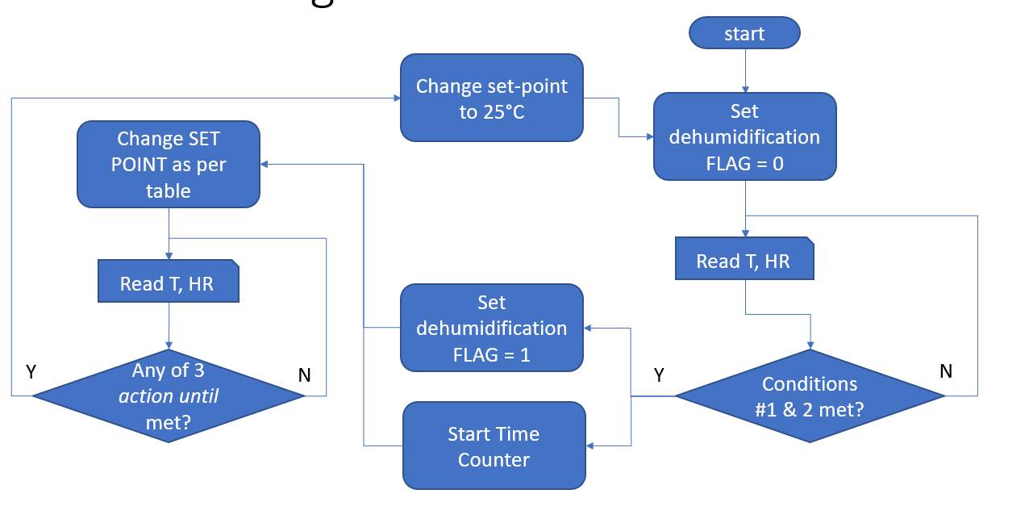

# Implementation

The script will initialize itself, by reading the configuration from the same config file, that is also used by the script controllino_modbus.py. The idea behind this is, that the script will automatically know if one or two HVACs are connected to the Cube Controller.

After the initialization, the the main functionality is implemented in a while-true loop with the following steps:

1. Read dl10 sensor to get temperature and humidity.
2. Calculate the setpoint for the HVACs depending on the temperature, humidity and the time elapsed since the current setpoint has been set.
3. Write the new setpoint to the HVACs.
4. Sleep for thirty seconds.